The Trail is intended to be followed in a clockwise direction. The first half of the Trail is mostly level and can be done separately to the more hilly second half.

If starting from the village stocks in Highergate Road please do not park a car on the double bend.
The stocks date from 1722 and are close to the original centre of the village, which was a crossroads called Towngate. Note the stocks and Trail interpretation board within the railed enclosure.

Huncoat Bank and the War Memorial
Cross the road to the inside of the bend and turn right to go round the front of the house called Bank Terrace. At the iron railings turn left up a curving grassy path into the recreation ground and climb the bank to the War Memorial erected in 1922. From here there is a panoramic view of the surrounding area which includes Hameldon Scouts, The Coppice, Darwen Tower, Great Harwood, the Hodder Valley, the Bowland Fells, Read, Pendle and Boulsworth Hill.

The Peace Garden and Hill House
From the memorial bear left and walk down the slope towards a gap in the nearest buildings where a wide track leads out into Burnley Lane. Turn left and cross over before the road end to reach the Peace Garden on the corner with Lowergate. Here, set in the wall is the Barraclough Date stone of 1768 together with an interpretation board. Cross Lowergate Road to return to the stocks passing by Hill House, the oldest surviving building in the area, with a cluster of rustic homesteads behind. At the stocks take the gravel drive by the end of Pipers Row to pass in front of Higher Hill House Farm and straight along the enclosed lane.

Spout House Fields
Ignore the first stone gateposts and stile on the left to reach a stile at the end of the lane, here turn left and follow the old hedgerow down the bank. (There is a clearer footpath down the bank on the far side of the next field strip but this is not a public right of way). Towards the bottom the ground is rough and boggy. Pass an overgrown stone stile and bear right by the fence over two plank bridges. A stile on the left is an alternative route round through the woodland, useful if the normal route is boggy. Cross the footbridge and bear right alongside the fence.

Bluebell Way Housing Estate
Go through the gap into the right hand field and turn towards the brick houses. The next stile is in the opposite diagonal corner. This brings you out on a tarmac path. Turn right and go straight through the Bluebell Way housing estate which occupies the site of the old Huncoat brickworks and Perseverance Mill. (Here in Yorkshire Street is an alternative starting point for the Trail with more parking space).

Clough Brook (deep wooded clough)
Cross over the railway at the signal box and level crossing and turn right through a gateway into the old pit top nature reserve. This was the site of Huncoat Colliery founded in 1885 and closed in 1968. Bear slightly left initially on the main path into woodland which leads to 3 flights of steps winding down into the bottom of the clough and a footbridge.

Nearer Holker House (RSPCA Sanctuary)
Cross the footbridge and go up the slope opposite passing near to the RSPCA Sanctuary. Bear right across fields aiming for the distant motorway footbridge (the Trail may get diverted here when a new link road is built). Go over the footbridge (constructed with the motorway in 1983) and keep to the right hand side of the field before turning left at a ruined wall leading down to the canal bridge.

The Leeds Liverpool Canal (opened in 1801)
Cross Clough Bank Bridge and turn right (or to avoid the steep slope turn left and double back underneath it), to walk eastwards along the canal towpath for 1½ miles. Along here the views open out over the Calder Valley towards Whalley Nab and Pendle. Pass under Altham Lane bridge (known locally as the Rabbit Run) and the two bridges at Shuttleworth Hall.
Shuttleworth House (small hall and farm)
Leave the canal at Higher Shuttleworth bridge (number 120) turning left and going over the bridge and then along the lane past Shuttleworth House. At the T junction by the farm turn left past the rear of the house and through a gate on the left into fields. Turn slightly right heading for the corner with the canal and motorway bridge. On reaching the canal turn right under the motorway underpass and follow a fenced track up steps beside the railway. The East Lancashire Railway through Huncoat opened in 1848.

Castle Clough Wood (deep wooded gorge)
Turn left over the railway line at crossing point.
Turn left in the field and enter woodland.
Turn right and follow the marker posts along a high level path above the gorge. Avoid stiles into fields on the right and keep to the main path in the woodland until it comes out onto a tarmac road.

If doing only the flat section of the trail turn right along this road and its ½ mile back to the stocks.

Mill Hill (car park and picnic site)
(An alternative starting point for the Trail).
Cross over the road bearing right through the car park, past the picnic benches and follow the path down to a stream and a footbridge.
Over the bridge turn right on the path through the woodland to reach a gate by another footbridge.
Here turn left, through a gate and up a steep bank with gorse bushes. Keep near to the gully on the left aiming for the nearest farm buildings that come into sight. On approaching the low wall with a gate keep to the right outside of the wall to avoid chained up dogs in the yard. Pass between poultry sheds and the wall to reach a stile onto the main Burnley road.

Hameldon Woods
Cross Burnley Road into the woods opposite.
The tracks in this woodland were opened in 2003 and form part of the Forest of Burnley.
Follow either of the main tracks climbing steadily within the woodland to come out at the top.

Herst (rough pasture)
Go over the stile and follow the rough path straight ahead to gain a rutted track running across the slope. Turn right along this track which shortly curves left climbing the hill. At a junction by a large rock and just before reaching a pond strike up the grassy shoulder to your right which soon presents a rising path skirting the steepest slopes and leading into a gully characterised by stone spoil heaps. Climb up the centre of the gully until flattish land is reached.

Hameldon Scouts (disused stone workings)
At the top of the gulley amid old stone workings turn right along a fairly level track-bed between mounds heading initially towards the distant farm but then veering left at a small quarry to cross the head of the gorge by a wall end and small waterfall.

Windy Harbour Farm
Cross the wall stile and stream and turn right along the gorge edge keeping the farm to your left. Cross a fence stile and keep to the rough and precipitous edge of the slope heading for the next stile below a pylon at the far end. Once over this turn left alongside the wall to reach a rough stony road.

The Kings Highway (ancient road)
Turn right down the stony road for 200 yards and just beyond a bend watch carefully for a gap in the wall on the left into the field. Keep left by the wall and at the next farm road (Miry Lane) turn left.
Go through the gate and then immediately right over a stone wall stile, bearing diagonally left across the field to a stile in a fence. Then, diagonally right to the next stone squeeze stile after which keep to the right hand edge of the field curving round towards the next farm.

Slate Pits Farm (farm buildings)
Turn right down the farm lane keeping left when you approach the main road to cross it by the underpass. This is the Accrington Easterly Bypass which opened in 1985. At far end of the underpass turn immediately right through a gate overlooking three small lodges.
Keep close to the fence on the right as it dips down
and then up again to a stile in the right-hand corner.

The Coppice
This open land is a country park bequeathed to the Borough of Accrington in 1909.
Follow the fence line overlooking the dual carriageway on over the summit to the front of the hill from where there is an aerial view of Huncoat.
Turn left along the front edge of the hill and when nearing trees keep them on the right to pass the highest point marked by the O.S. trig column.
Aim for the monument on the end of the hill.
The swathe of trees blocking some of the views were all planted in 1972/73.

Peel Park
The monument is to the benefactor of the country park William Peel of Knowlmere. From this point there is an aerial view of Accrington. Turn left keeping above the tree line to follow the main path which gradually descends. At a major cross-paths turn down to the right through the trees. Keep straight on down the main track which gradually descends to the park entrance beyond the bowling green.

Hillock Bank (site of an old Farm)
Go through the gate, across the spare land used as a car park for the bowling green and then bear right along the rough road between allotment pens. When the road swings left keep straight on by the fence past more pens and along a passageway fringing a derelict poultry farm. (The route here may get diverted if new houses are built on the site). The passageway turns a left corner and comes out down the side of the Whitaker Arms pub. Cross over Burnley Road and turn right past the main gate of the cemetery (opened in 1864).

Cemetery and Within Grove estate
Before the exit gate out of the cemetery look for the footpath sign through the gap in the wall opposite to Hillock Vale Mill Shop. Cross the grass diagonally right to reach the driveway leading down to a cross-roads. Turn right and then look for an iron gate on the left leading into a passage through the houses. At the end of the passage turn right past the front of the shops and cross straight over Bolton Avenue into Oakhurst Avenue (between the Newsagents and the church). When the road bends to the right branch off straight across the top of the playing fields keeping all houses
to the right.

Spout House Woodland
Continue past the children's play ground across a field and over a stile into woodland. Turn right and follow the main track up through the woodland. Once over a plank bridge turn right to reach the top of the woodland.
Seek out the two Baptist Union foundation stones set in the high garden wall covered by creepers just to the right of where you emerge into the lane then turn left to follow the signed passage around the outside of Spout House farmyard. Keep in the walled lane known as Cleggs Lane which gradually rises behind the houses until you come back to Higher Hill House Farm and the end of the Trail at the stocks.
Introduction

Huncoat is a small village near Accrington situated on the slopes of the Pennine hills below the 1,340 feet high Great Hameldon.

The place name was recorded in the 11th Century Domesday Book when Lancashire was still largely covered by peat moss and woodland.
In medieval times Huncoat was a cross-roads for two packhorse trade routes and expanded in the 19th Century with the Industrial Revolution.

Between the two world wars the corridor alongside the railway line was heavily industrialised with collieries, coke works and brick yards.

However, in recent decades there has been a tendency towards rural regeneration and there are now many green open spaces and landscapes with striking panoramic views.

Huncoat has become a delightful blend of fields, woodlands, residential development and hill scenery.

Starting Points

The village stocks in Highergate Road.
National Grid Reference SD777304 or
behind the signal box in Yorkshire Street. National Grid Reference SD772307 or
The Mill Hill picnic site in Hapton.
National Grid Reference SD787308.
It is recommended that the Ordnance Survey Explorer Map 287 “West Pennine Moors” is used in conjunction with this leaflet.
Watch for the way-marker plates as an extra guide but be aware that they tend to vanish over time.
Huncoat is 1 mile east of
Accrington on the A679 Burnley Road.
Turn into the village at the Griffins Head pub.

Car Parking
Roadside only in the village.
The nearest public car park is at Mill Hill picnic site in Burnley Lane which is a good alternative starting point for walking The Trail.

Public Transport
There is a frequent bus service from
Accrington town centre and a
railway station in the village.

The Trail was devised by
Roy Chetham in conjunction with
The Huncoat Community Forum
The PROSPECTS Foundation
and
Hyndburn Borough Council

Publication of this
guide was funded and supported by:-
Huncoat Area Council
Hyndburn & Ribble Valley CVS/HyCEN
Neighbourhood Renewal Community Chest
& Lancashire County Council
Green Partnership Awards:
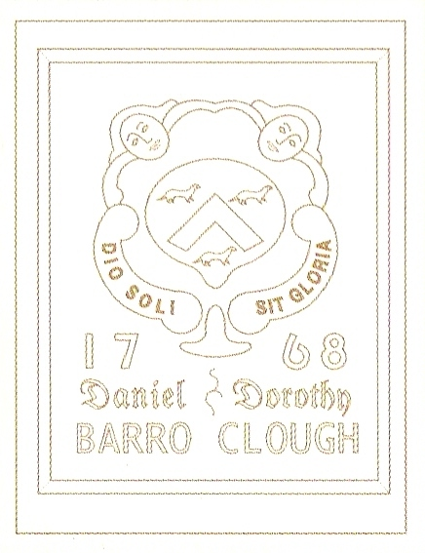
Grants for environmental action in Lancashire

The watermark is the coat of arms of the Barraclough family and can be found on the date stone preserved in the Peace Garden.
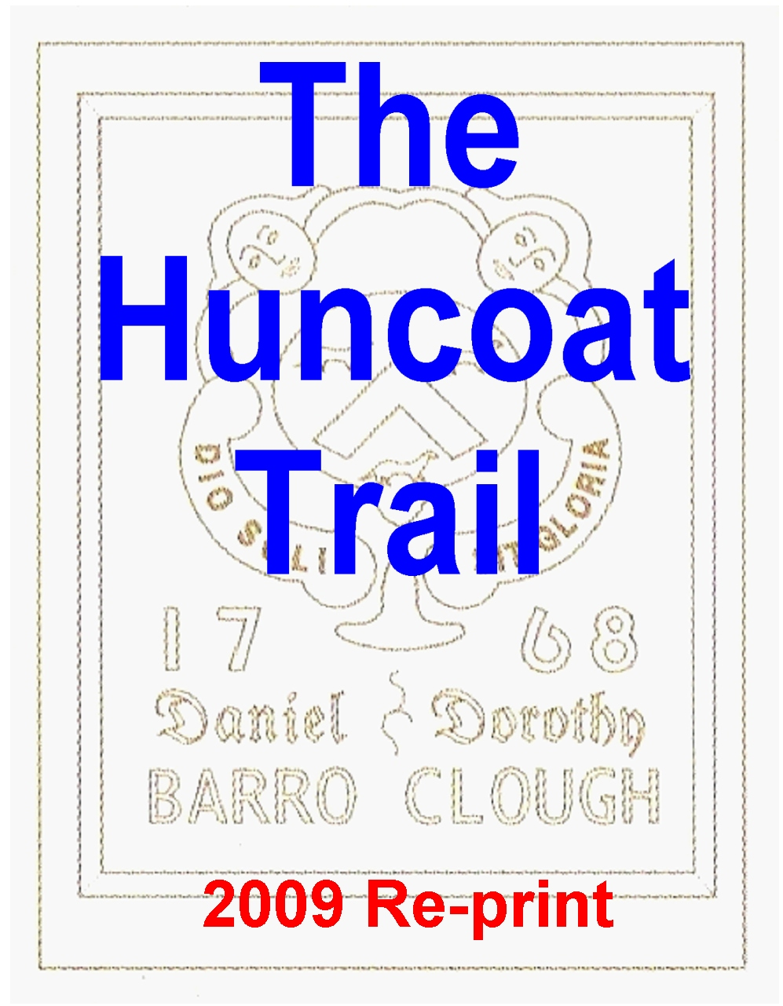

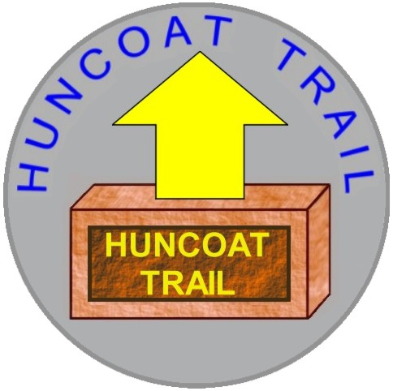
A 9 mile circular walk roughly following the old parish boundaries of the historic village of Huncoat

The walk can also be done in
two separate 5 mile sections

Look for the distinctive
way-marker plates
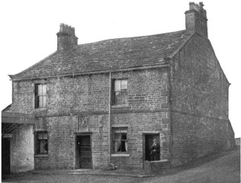
OLD HALL FARM

