Hidden Huncoat
A Local Heritage Walk

Devised by Roy Chetham

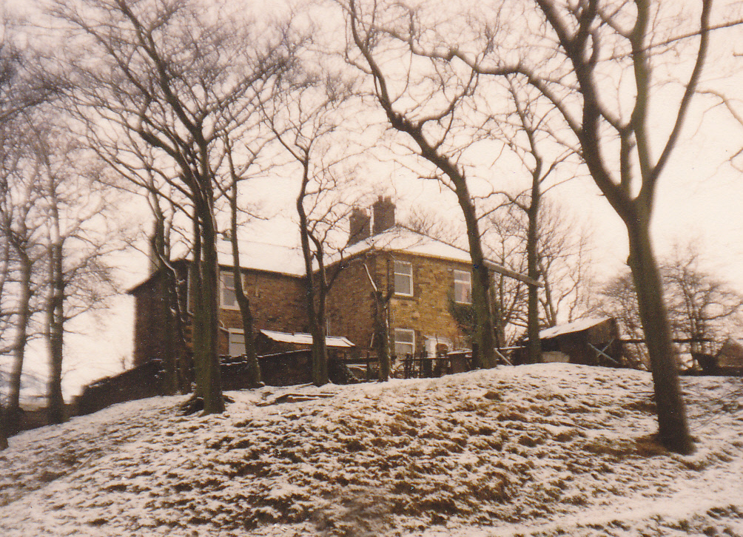

A 3 mile gentle walk around the centre of Huncoat looking at aspects of its long history. Spend at least 2 hours to complete it so that you have time to stop and study all the points of interest.

St Augustine's Church is a clear landmark that is easy to find and has scope to park a car. A Chapel of Ease was founded here in 1886 followed by a full Church being consecrated on 30th November 1909 by the Lord Bishop of Manchester. Although there were many coal mining workings under this area a pillar of coal was left undisturbed under the church to avoid subsidence.

Cross over the road to the bottom of the green. This road was originally called Brownbirks Lane but was extended in 1948 and re-named Bolton Avenue after the eminent Bolton Family who were the owners of Huncoat Colliery. The dip in the road underneath the railway bridge was made at this time to create enough height clearance for double deck buses.
Go along Within Grove to the first house on the left. This estate of 218 Easiform Council Houses were built by John Laing & Co. Ltd in 1956.

Turn left up the ginnel by number 1 into the Cemetery.
Then turn right onto the long drive going right through to the other end.
The cemetery was opened in 1864 and had its original entrance at the end of the curved drive leading down off Burnley Road.

Exit the cemetery into Whitewell Road and turn right following the high wall. When Whitewell Road bends to the left keep to your right on a footpath. This brings you to a bridge over the railway line. Once over the bridge turn right onto a rough track. This area behind the cricket ground was a junction for the network of mineral lines which developed from 1896 onwards to serve the brick, coal and coke industries.

Follow the direction of the railway line but keep to the left and lower track to avoid a steep descent later. This section may soon be upgraded into a cycle track (part of the Hyndburn Greenway). Continue behind the works buildings until a T junction is reached where you can turn left into Newhouse Road.

This is Huncoat Industrial Estate opened in March 1963. The first firm on it was RGS Electro Pneumatics Ltd which later became part of Pneumatrol in Oswaldtwistle. Senator who are now the largest occupier, was founded in 1976/77 and came to Huncoat in 1981 with a small unit of 9,800 square feet. They have now grown to be the largest manufacturer of office furniture and workplace solutions in the UK with another 216,000 square feet on Altham Business Park.

Turn right along Newhouse Road and left down Bolton Avenue to reach Whinney Hill Road. Here turn right past Oakbank Terrace and the entrance to Holker House RSPCA Animal Sanctuary. The lane to Holker House was spanned by a trestle viaduct carrying a mineral railway until the 1960’s.

As you begin to climb Enfield Road turn left between the carved posts entrance into a Nature Reserve. This was created in 2002 with tree planting and path laying and is often referred to as the old pit top but was in actual fact just part of the mineral railway network. (The true pit top and colliery buildings were at the other end of Huncoat railway station by Meadow Top Bridge.) You can wander on various paths within the nature reserve but generally keep right to emerge at the top end by the railway level crossing.

Cross the railway (using the footbridge if the gates are closed). The East Lancashire Railway opened to Huncoat on 27th May 1848. The original station was off Altham Lane but was moved in 1881 to the south side of the level crossing. Its current location north of the level crossing was adopted in 1902.
Turn right over the railway along a curving street that was once a row of terraced houses named Highbrake.

On your right mostly covered now by housing is the site of Perseverance Mill. Huncoat Cotton Mill was built by John S. Grimshaw in 1853. It was later called Perseverance Mill and sometimes Highbrake Mill. Spinning and weaving ceased in 1941 and it was then used by the War Dept for storage until being demolished in 1955.

Continue straight through Bluebell Way Housing Estate which was built in 2004 on the site of the Redac Brickworks. The Huncoat Plastic Brick and Terra Cotta Co. (trademark Redac, based on “Red Accrington”) was founded in Yorkshire Street in 1894. Ore originally came from a quarry behind the works but later from the Coppice by means of a tramway and then an aerial ropeway. The Redac Brickworks closed at the end of 1992 and was demolished in 1999.

Continue along the Greenway cycle path to the right of the block of flats named Honeysuckle Court but after the dip where there is an overgrown pond and soakway branch off left over a stile. This brings you into the new plantations in Lower Spout House Woods. Those on your left hand side were planted in 2006 and those on your right hand side in 2014. The paths were laid in 2015.

Follow the main surfaced path to the first junction at a Peak and Northern Footpath Society sign. Go left here and over the footbridge. Ignore stiles on your left into fields and keep to the surfaced path uphill to the next junction. Here turn left up a wide grassy track going steeply up the hill.

At the top you reach Hill House Lane an ancient walled road. The Domesday Book of 1086 recorded that King Edward had held about 250 acres of land here in Huncoat, approximately the same size as the area now bounded by Burnley Road, Bolton Avenue, Enfield Road, Station Road, Lowergate and Highergate. Looking back most of this area is now spread out below you.

Go left along the lane behind bungalows and across the top of some narrow strip fields which are remnants of medieval farming practice. Turn right to gain Lynwood Road. Fish Lane was officially re-named Lynwood Road in 1933. It got its original name because of a farm called Fish House situated on the corner just above the school. It led into Scatchen Lane that went over Whinney Hill to Church.

In Lynwood Road go right towards the Black Bull Inn on Lowergate Road.
Early in the 17th Century the first beer house in Huncoat; the Black Bull was established on the Royal Highway.
The present day structure of the Black Bull dates from around 1780.

Turn right up Lowergate Road and proceed to the junction with Burnley Lane.
This junction, Towngate, was historically the central area of Huncoat. The word gate derives from Anglo Saxon and means street. Ancient Royal Highways formed a crossroads at Towngate. One from Clitheroe coming via Altham and the Kings Highway to Haslingden and the other from Accrington to Burnley via Millgate (Cleggs Lane). In 1722 John Hacking of Huncoat perfected one of the earliest cotton carding machines. He and his wife lived in a cottage in Towngate and are buried in Altham church yard. The east window of the church commemorates several members of the Hacking family.

On the junction is Hill House one of the oldest residences in the area. A “Richard of Hill House” was named in documented records dated 1425 but the present building is 17th Century. On the opposite side of the road is the Peace Garden created by the Huncoat Community Forum in April 2011. Originally this was the site of Highergate or Howard’s Farm which was demolished in 1960. Preserved in the back wall of the Peace Garden is the famous Huncoat Old Hall Farm tablet dated 1768. It bears the names of Daniel and Dorothy Barroclough and the Arms of the Birtwistle’s because, as Oliver Birtwistle’s daughter she was the last of the family line. The datestone was originally over the doorway of Huncoat Old Hall farmhouse situated on the crest of Highergate Road below Huncoat Bank.

A Baptist Church in Burnley Lane was demolished in 1965 because of dry rot and two foundations stones are preserved in a garden wall in Spout House Lane. The site of the church is now marked by the bungalow “Chapel House”.
From the Peace Garden walk along Burnley Lane noting numbers 5 and 16 which were once small shops opposite each other. The latter on the corner with Towneley Avenue being R Suthers Grocer & Confectioner.
At number 17 turn right up onto the recreation ground and climb to the War Memorial.

In 1878 land on the eastern and southern flanks of Huncoat Bank was granted to the village as a recreation ground by the Peel family renown for founding the police force. The recreation ground of just over 5½ acres was purchased by the Parish Council from the Earl of Abingdon and Trustees on 14th July 1911. On 29th April 1922 the un-veiling Ceremony of the memorial was performed by H.H. Bolton Esq.

Turn right at the war memorial and follow the tree line gradually down to the field corner. Here a path through the bushes leads into Highergate Road. Almost opposite is where Huncoat Old Hall once stood but it was demolished in 1969 and its farmland is now the Old Hall Drive and Sutton Crescent housing estate.

Cross over to the Stocks. Records show that as early as 1532 Huncoat had some village stocks where people were fastened for wrong doings. The date inscribed on the stocks is 1722 but were clearly in use much earlier. The Huncoat Community Forum refurbished the village stocks in 2013.

Go down the side of the stocks and turn left into Cleggs Lane a narrow ginnel behind houses. Look out for remains of the old stone walls and note how wide the road once was when it was a main highway. It leads to Spout House Farm. At the end of the 18th century and before the railway was built James Allen of Spout House Farm ran local stage coaches, the horses for which were changed at the Walton Arms and brought up to be stabled here. The route from the farm to the stocks became known as Clegg’s Lane because the Clegg family lived in Spout House Farm for over 100 years.

Follow the diverted path in the ginnel around the farm yard and you come into Spout House Lane.
Here set into the high garden wall on the left are the two Baptist Union foundation stones mentioned earlier that were salvaged and placed here in 1986 to commemorate the 900th Anniversary of Huncoat.
Nearly opposite to the foundation stones is a small iron gate into Higher Spout House Woods where you go next. The mature trees in here are about 100 years old but it is likely the stream clough was always wooded. Go down through the woods and left over the footbridge. Take the next exit from the woods on the left into a wild flower Meadow. When the new trees were planted in 2014 this area was left clear as it had been identified as a habitat of wild flowers. Some examples being Knapweed, Autumn Hawkbit, Daisy, Red Clover, Self-heal, Buttercup, Woodrush, Pignut and Vetchling.

St Augustine’s Church and the end of this walk is now in sight ahead but there are still interesting things to look for. The aerial ropeway to Redac brickworks mentioned earlier came straight down from Rake Head Quarry over Burnley Road, behind the houses on the east side of Oakdene Avenue and across the fields to your right. It was dismantled during the 1960’s.

Continue across the top of the playing fields past the ends of Oakdene Avenue and Oakfield Avenue. Under the latter runs the Haweswater Aqueduct and if you look to the right you will see a pumping house.
This was laid through Huncoat in 1951 running from Haweswater in the Lake District to Heaton Park Reservoir in Manchester. The pipes run up the centre of the playing fields and under Burnley Road to the old reservoir site. The pipes are 4 feet in diameter and supply water to Accrington before going 300 feet under the hills to Rising Bridge, Haslingden and Townsend Fold, Rawtenstall. The Huncoat Tunnel is 8ft.6ins diameter and takes 100 million gallons daily at 2mph.

Join Oakhurst Avenue back to St Augustine’s. Dozens of prefabs known as “Sawdust City” were erected in 1939 in the area of Woodside Road, Oakfield Avenue and Oakhurst Avenue extending both above and below the Church. These were cleared in the 1950’s to make way for 21 blocks of 2 storey flats whilst the rest of the land was turned over to playing fields.

The name Huncoat is probably Anglo-Saxon in origin, referring to a lowly farmer. Around 1042 Leofwine an Anglo-Saxon Thane presided over a domain that included Huncoat from a manor house at Altham. By 1241 his descendant Edward inherited rights to various lands including Huncoat hence this line of the family acquired the name de Huncoat.

