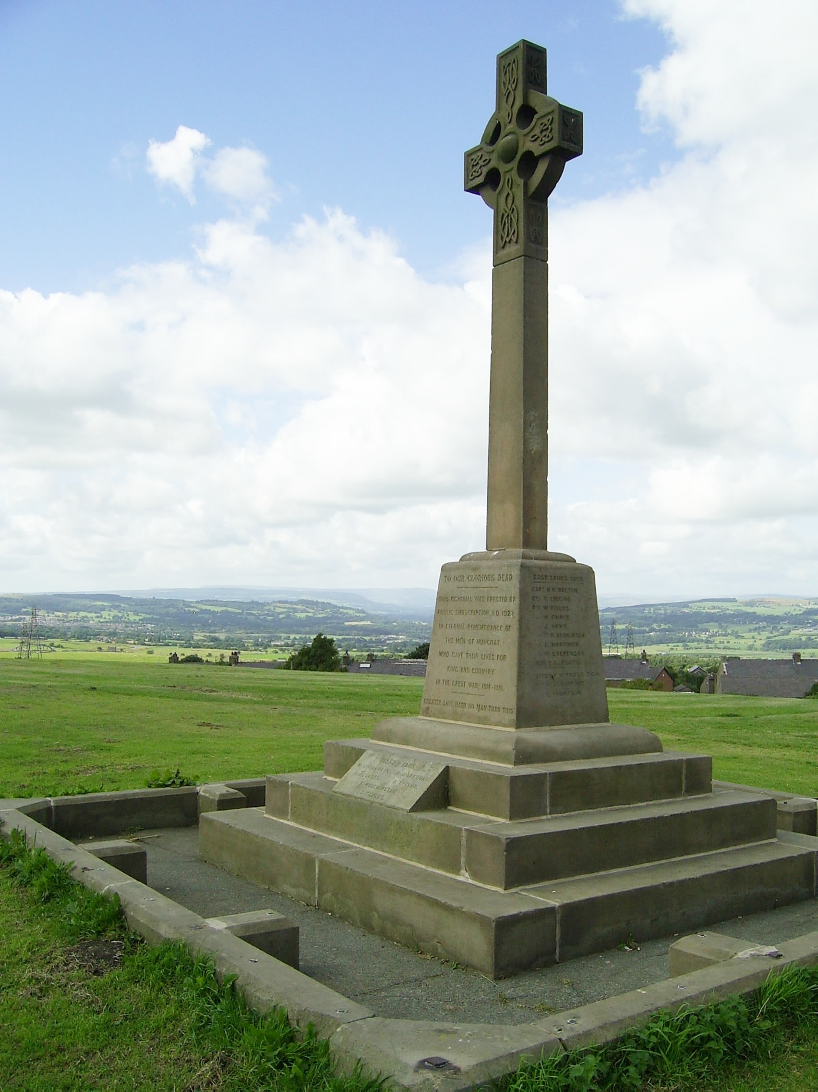
15 Peel Park and the Monument The top of the Coppice is 830 feet above sea level. The monument is to William Peel of Knowlmere Manor in the Hodder Valley who in 1909 gave the land to the town.

16 High Riley Here we have the oldest surviving buildings in the Accrington area. The date on these cottages is 1628 although the site is known to have been an important seat of residence in 1241.
Walking into History
17 Gambler’s Caves The industrial revolution brought a new culture into the area with immigrant workers who were prone to secret gambling in the hills.

18 Mary’s Holy Well O.S. Maps show a feature here labelled May Road Well. This is an ancient holy well and is in fact carved roughly with the words "Mary's Holy Well," although it has also been described as "Mary Hoyle Well." It is a natural spring covered by a 7 inch thick stone slab, 94 inches long and 51 inches across. It may be significant that The Virgin Mary was celebrated by the Catholic Church in May and that this May Road Well, being situated only 440 metres off the Kings Highway beside a connecting track leading over to Rossendale, was well frequented by travellers in bygone days. Up until the end of the 18thC places like Mary's Holy Well were places of pilgrimage and fairs on the first Sunday in May.

Today the well is rather neglected and overgrown and it is believed that the spring water was long ago diverted to nearby reservoirs. Holy wells were frequently pagan sacred sites that later became Christianised. The term 'holy well' is commonly employed to refer to any small water source which has some significance in the folklore of the area where it is located.

19 Hameldon Hall were shown on the OS map of 1844 but the site existed as early as 1608. Despite its grand name Hameldon Hall was never more than a small hill farm.

20 Kings Highway The Kings Highway was an ancient pack horse route from Haslingden to Clitheroe.

Directions for the Huncoat to Hameldon Trail

The numbers refer to the historical points of interest listed on pages 6 to 8.

Start at the Griffin’s Head in Burnley Road 1.
Set off along Highergate Road past Sunnyside House. At the iron railings branch off to the right up a steep rough slope to the War Memorial 2. Continue over the hill towards a gap in the houses leading onto Burnley Lane. Turn left to reach the Peace Garden 3 on the corner with Lowergate Road.
Walking into History

Cross Lowergate Road and keep left past Hill House 4 and Pipers Row 5 to reach the village stocks 6. From the stocks take the gravel lane to the right at the end of Pipers Row and turn left down the narrow footpath of Clegg’s Lane 7 behind a housing estate.

Follow Clegg’s Lane right to the end at Spout House Farm 7 and just past the farm look for the Baptist Union foundation stones 8 set in the high wall on the left. Turn right through a small iron gate into Spout House woodland 9. Go down the woodland path turning left over a footbridge. Take the next exit on the left into meadowland.

Cross the top of some playing fields 10 to reach St Augustine’s church 11 on the corner of Bolton Avenue 12. Continue straight ahead with Ambleside Close on the left but then take the narrow passage on the left through to the cemetery 13.

Head diagonally for the main gates cutting through the memorial rose gardens and emerge into Burnley Road at the Whitakers Arms 14.

Go up the track to the right of the Whitakers turning right along a narrow passage between garages and then allotments. Bear left at the next junction and left again before reaching the bowling green. Go through the gates and start climbing the main track straight ahead through the trees. Watch out on the right for a minor track going steeply uphill and take this to reach the trig pillar on the summit of the Coppice (843 feet).

6 The Stocks Fastening offenders in stocks in Huncoat was first recorded in 1532 but the current stone uprights are dated 1722. In 1906 when Highergate Road was widened the stocks were re-positioned within iron railings.

7 Spout House Farm Prior to the railway being built James Allen of Spout House Farm ran a local coach service, the horses for which were changed at the Walton Arms and brought up here to be stabled. The track from the stocks to the farm is called Clegg’s Lane because a family called Clegg lived here for over 100 years.

8 Baptist Union foundation stones These are set into the high garden wall covered by ivy and were put here in 1986 to commemorate the 900th Anniversary of Huncoat. They were salvaged from the demolition of the church in 1965.

9 Spout House Woodland This is a local beauty spot which the local council are expanding with new woodland planting. Some of the mature trees are over a hundred years old but there is no evidence that this is part of an ancient woodland.

10 Haweswater Aqueduct The pumping houses on the playing fields serve the four 4 foot diameter water pipes constructed in 1951 running from Haweswater Reservoir in Cumbria to Heaton Park in Manchester.

11 St. Augustine’s Church A Chapel of Ease began here in 1886 and the present church building was consecrated in 1909.

12 Bolton Avenue Before 1948 this was just a lane to Lower Brownbirks Farm but it was re-made and re-named to honour the respected Bolton family who owned Huncoat Colliery.

13 Accrington Cemetery Opened in 1864.

14 Whitakers Arms The oldest known buildings on this site were Woodnook Farm dated 1756 and the pub probably evolved when the Burnley Road turnpike was opened in 1838. Certainly it seemed well established by the time of the OS Map in 1844. Between 1868 and 2005 the pub was known as The Cemetery.
At the next wall take the stile to the left and down the rough field back to the Kings Highway 20. Turn right and then branch off left across Moleside Moor. A clear path curves gradually to the right and descends to a stone wall with two stiles. Take the right hand one leading down to a farm lane.

Take the farm lane down to the dual carriageway and through the underpass then turn sharp right below the road dipping down and then up again to a stile. Keep right and go over the hill following the path beside the dual carriageway until a left turn brings you into Kingsway and a return to the Griffin’s Head.

Historical Points of Interest

1 Griffin’s Head pub This was built by Shaw’s Brewery in 1838 although it was originally for a short time called the Cross Gates because it was at a cross roads on the new turnpike.

2 War Memorial It is known from OS maps that there was a cross on top of Huncoat Bank before 1844 and in 1878 the land was bequeathed to the village by the Peel family famous for founding the police force. It is known locally as the Rec because it is a ‘recreation ground’. The War Memorial was unveiled on 29th April 1922. It was damaged by a gale in January 1936.

3 The Peace Garden The idea for this garden was first mooted in 2003 by Geof Coglan as Chairman of the Huncoat Forum but it took until 2011 to be completed.

4 Hill House A homestead at Hill House is known to have existed on the site as long ago as 1425 but the current Tudor building dates from 1660. The intersection next to Hill House was the original centre of the village called Towngate where the pack horse route of the Kings Highway from Clitheroe to Haslingden crossed Millgate from Burnley to Accrington.

5 Pipers Row The original row of cottages known as Pipers Row had got its name because a musical family had once lived there. The new Pipers Row was built in 1992 on the footprint of Hill House Barn.
Turn right on the top to visit the Peel Monument 15 which is a great viewpoint. From here follow the surfaced path descending gradually with woodland on your right. The surfaced path makes a sharp right at a junction but here turn left first and then take the right fork into thick woodland. Cross straight over a main track and head for the Plantation Reservoirs either by stepping stones over a culvert to the top dam or along the middle dam. Either way you reach a field sloping up to the rough road of Plantation Road.

Turn right down the rough road for a short distance before forking left into a green track climbing again. This leads to the collapsed barn of Brocklehurst and over a stile beyond to the woodland of the same name. Go over a footbridge and out of the other side of the woodland crossing two fields with New High Riley (a farm with a tower) on your right.

A stone wall stile brings you into another rough road called Sandy Lane. Here turn left past the front of the ancient High Riley Cottages 16. Then take the rough road first branching right and then left through the underpass to continue up Sandy Lane past Blueslate cottage. Keep straight on to the left of the cottage into the fields to reach a T junction with the rough road of the Kings Highway 19. Turn right through a gate and left over a stile to go up beside the drained Hameldon reservoir. Here on the right beyond rough pasture are stone quarries known locally as Gambler’s Caves 17.

Our trail keeps to the stone wall on the left until reaching Mary’s Holy Well 18 a small depression within a dishevelled barbed wire fence. A stone stile on the left leads to the cairned path to the summit of Great Hameldon. From the trig pillar at 1,342 feet can be seen a wide panorama including Blackpool Tower.

Turn left at the summit visiting the cairned viewpoint then pick up the clear track a bit further left descending the steep front of the hill. At the bottom some ditches and boggy ground have to be negotiated where a fenced strip with rushes leads to the ruins of Hameldon Hall 19. Beyond the ruins there is a short stretch of rough ground before a wide green track is found heading diagonally right.
